**Test Case 0006 (part 1)**

**System:** VirtuCardsClient & VirtuCardsHost

**Description:** Tests that propagation delay between user actions and the appropriate response from the server

**Severity:** 2

**Instructions**

1. Start VirtuCardClient application
2. Click the button labeled “Sign In”
3. Enter “virtucards01@gmail.com” into the text input labeled “Enter email…”
4. Enter “Testing1” into the text input labeled “Enter password…”
5. Press the button labeled “Login”
6. A window should appear saying “Login Success”
7. Press the OK button that appears on that window
8. Start VirtuCardHost application
9. Repeat steps 2-7 but on the VirtuCardHost application
10. The checkbox “Allow Host to Join” should be checked on the host
11. Press the Create Game button
12. In the VirtuCardClient application enter the 6-character room code found on the host’s screen into the field labeled “Enter Code…”
13. Press the Join Game button on the client
14. After the name TestCase0001 appears in the player list on the host side, press the Start Game button
15. Evaluate the time it takes for the client to change the screen after the Start Game button has been pressed
16. Play something from the Client-side
17. Evaluate the time it takes for the host-side to update the UI after a player has played something

**Expected result:** Every time the client has played something, the host side screen should instantly update to the correct page or according to the move the Client has played.

**Test Case 0006 (part 2)**

**System:** VirtuCardsClient & VirtuCardsHost

**Description:** Tests that propagation delay between user actions and the appropriate response from the server

**Severity:** 2

**Instructions**

1. Start VirtuCardClient application
2. Click the button labeled “Sign In”
3. Enter “virtucards01@gmail.com” into the text input labeled “Enter email…”
4. Enter “Testing1” into the text input labeled “Enter password…”
5. Press the button labeled “Login”
6. A window should appear saying “Login Success”
7. Press the OK button that appears on that window
8. Start VirtuCardHost application
9. Repeat steps 2-7 but on the VirtuCardHost application
10. The checkbox “Allow Host to Join” should be checked on the host
11. Press the Create Game button
12. In the VirtuCardClient application enter the 6-character room code found on the host’s screen into the field labeled “Enter Code…”
13. Press the Join Game button on the client
14. After the name TestCase0001 appears in the player list on the host side, press the Start Game button
15. Evaluate the time it takes for the client to change the screen after the Start Game button has been pressed
16. Play a normal game

**Expected result:** Every time there is a wait time on the client-side, the waiting UI will show up that says “Loading…”.

Pictures

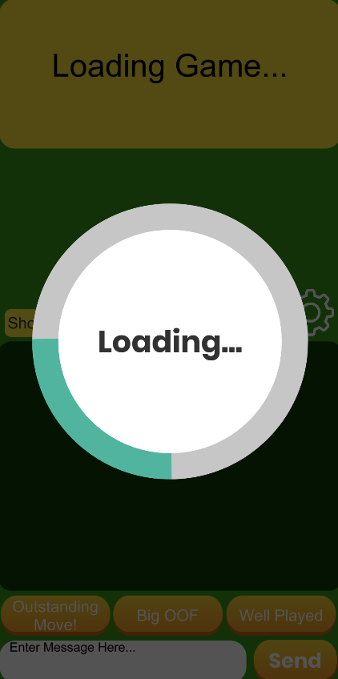

Whenever there is a delay/waiting period in the game, this UI will show up until the game is ready, which will usually be less than a second.